 COMPREHENSION THROUGH VISUALIZATION

BY: LISA STODDART

Occupational therapist, behavior therapist, MSC Educational Psychology

Similar programs that can be accessed at select schools, programs abroad and at Therapy Plus

1. Visualizing and Verbalizing by Linda Mood Bell <https://lindamoodbell.com/>. Also available at Therapy Plus
2. The Davis Method (access online)

visualization

* Helps us to pay attention to detail
* We use prior knowledge to make pictures and make connections
* As we read, we create mental images of what is happening in the story
* We can create characters and the way things look by our own imagination

**Symptoms of Weak Concept Imagery (by Linda Mood Bell)** Difficulty with

1. Critical, logical, abstract thinking and problem solving
2. Written language comprehension
3. Oral language comprehension
4. Following directions
5. Expressing language orally
6. Expressing language in writing
7. Grasping humor
8. Interpreting social situations
9. Cause and effect
10. Attention and focus
11. Responding to a communicating world
12. Mental mapping

STEPS TO VISUALIZING

* DESCRIBE A PICTURE
* DESCRIBE A WORD
* DESCRIBE A SENTENCE
* DESCRIBE A PARAGRAPH
* DESCRIBE A SEQUENCED PICTURE
* DESCRIBE A STORY

DESCRIPTIVE WORD CUES (MAKE INTO FLASH CARDS)

WHAT SIZE COLOR NUMBER SHAPE/LOOK WHERE

BACKGROUND WHEN SOUND

PROCEDURE

**STEP 1**

**VISUALIZING A PICTURE**

CUE WORDS

1. Put the cue words out on the table – flash card style
2. Touch each word ad have the child describe the picture according to each of the cue words
3. When the child knows the cue words well, turn them upside down
4. Have the child touch the cue word which is upside down and call the word eg. What, where etc.
5. Eventually remove the cue cards as the child should know them

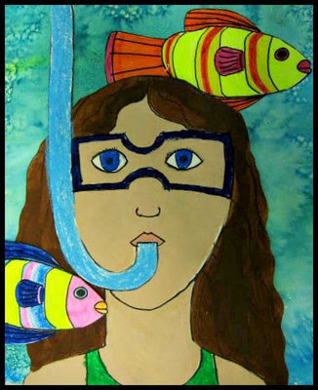

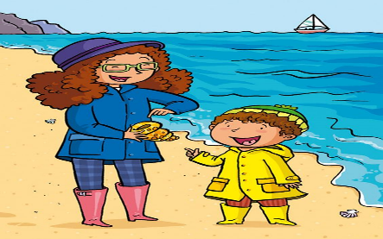

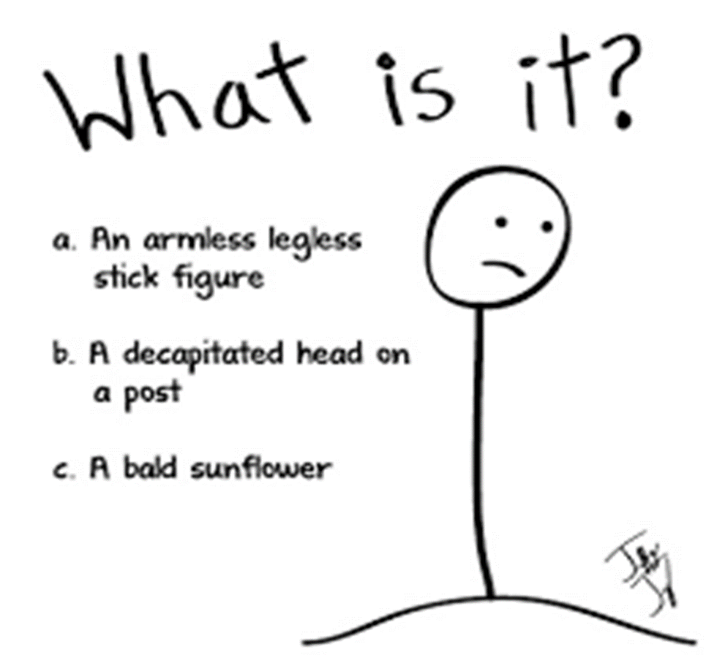**WHAT SIZE COLOR**

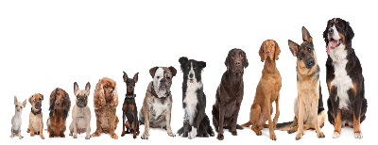 **HOW MANY**

**SHAPE WHERE MOVEMENT BACKGROUND**

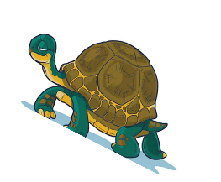

**WHEN SOUND**

** **

**REPEAT PICTURE VISUALIZING MANY TIMES WITH MANY DIFFERENT SAMPLES UNTIL PROFICIENT**

**STEP 2 -**

**PICTURING A WORD EG. DOG (CONTINUE TO USE THE DESCRIPTIVE WORDS)**

|  |
| --- |
| The dog is color look movement background size where sound |
| The dog is brown fluffy running trees large park barking |

**REPEAT PICTURE VISUALIZING MANY TIMES WITH MANY DIFFERENT SAMPLES UNTIL PROFICIENT**

**STEP 3**

**PICTURE A SENTENCE eg. THE DOG WAS WALKING DOWN THE ROAD ONE DAY**

**Picture: The large brown fluffy dog was walking down the hot black asphalt road one bright and sunny day.**

**STEP 4**

**PICTURE THE PARAGRAPH**

A DOG NAMED CRAVEN WAS WALKING DOWN THE ROAD ONE DAY. HE SAW ANOTHER DOG WITH A BONE. HE STARTED TO CHASE THE DOG TO GET THAT BONE. THE DOG WITH THE BONE RAN ONTO A BRIDGE AND DECIDED TO TRICK CRAVEN. HE STUCK HIS HEAD OUT OVER THE WATER TO CREATE A REFLECTION WITH THE BONE IN HIS MOUTH. FINALLY CRAVEN CAUGHT HIM UP. HE SAW THE REFLECTION OF THE BONE IN THE WATER AND DOVE IN TO GET IT. TRICKED YA SAID THE DOG AND RAN OFF.

**STEP 5**

**PICTURE AND DESCRIBE A STORY**



**OTHER IDEAS LET KIDS DRAW THEIR STORIES**



**SEQUENCED PICTURES**

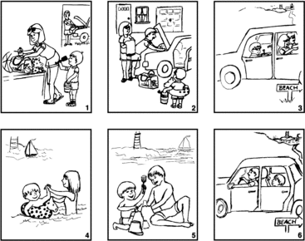

**WRITING ABOUT WHAT WE HAVE PICTURED**

**A DOG NAMED CRAVEN**

**USE OF PICTURE BLOCKS . TOUCH THE BLOCK AND RECALL THAT PART OF THE STORY**

**BEGINNING**

1. One day, a dog named craven was walking down the road



1. He saw another dog with a bone in his mouth



1. He started to chase that dog to get that bone and the

Dog ran onto a bridge



1. The dog tricked Craven by putting his head over the

Water to make a reflection of the bone



1. Craven saw the reflection of the bone in the water and

Jumped into the water to get the bone. The dog had

Surely tricked Craven

NB. Word understanding

In order for kids to read and create words, they do need to be at a certain level. Also you can use the internet to make pictures of words for them to understand, also describe in different words what the word means, also make analogies that hey may be familiar with so they ‘get’ the word, and also draw what a word means.